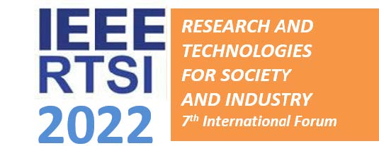

Special Session on
Electrical machines and drives for green marine activities
Organized and co-chaired by:
John Prousalidis, National Technical University of Athens, GR, jprousal@naval.ntua.gr
Jean-Frederic Charpentier, French Naval Academy, FR, jean-frederic.charpentier@ecole-navale.fr
Call for Papers
This special session is devoted to research work covering the fields of new trends in electric power systems comprising electrical machines contributing to new generations of marine electrical systems. These systems include energy/propulsion system for new generation of electrical or e-hybrid propulsion ships and marine renewable energy systems as these two topics are subject of intensive dual research. This is why ship power and marine renewable energy (MRE) systems are in the scope of this SS.
Topics of interest include, but are not limited to:
• Specific marine systems dedicated to propulsion or marine energy associating hydrodynamics and electromechanical systems (e.g. pods, thrusters, tidal turbine, wave energy conversion, etc.)
• Unconventional electrical machines and drive dedicated for electrical Marine Propulsion or marine renewable energy (multiphase, multi star machines, Transverse Flux machines, axial flux machines, Rim Driven machines for propeller and turbine, linear machines for WEC, etc)
• Onboard, offshore, near-shore Renewable Energy sources and their coordination with electrical machines (e.g. PV’s, Fuel Cells, kites, Offshore Wind Power, tidal generators, wave energy converters Hydro generators for sailing vessels)
• Energy storages systems to be associated with naval or marine energy systems (batteries, flywheels, SMES, supercapacitorsystems, etc.)
• Hybrid energy configuration and control for optimizing the global marine systems efficiency and behavior.
• Electric Energy Saving Devices for electrical machine green shipping (e.g. power converters, soft starters,etc.)
• The ports as energy hubs: MRE deployment in ports, cold ironing and reverse cold ironing, energy buffering, battery swapping, and energy clouding.
• Electric Power, Management and Control System (EPMACS) for ships and MRE
• Direct Current applications for increased efficiency in ships and offshore renewable energy systems
• Offshore Renewable Energy transportation, storage and conversion: Power to X, H2 production from MRE, optimization of offshore electrical connexion, etc.
• Waste heat recovery units
• Hybridization of marine energy systems (ships and MRE)
Submission of papers: deadline followsthe deadline for the regular papers.
All the instructions for paper submission are included in the conference website: https://ieeefrance.org/author-guidelines/

